Can’t tolerate ‘Gluten’? Are you sick of eating boring meals? Looking for something new?
Try this!! A Gluten Free Recipe
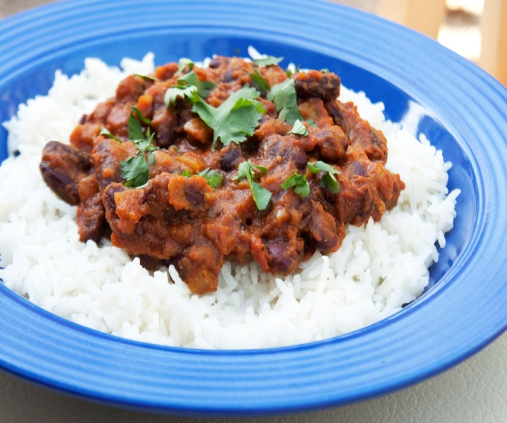
Kidney Bean Curry and Rice
Ingredient:
Serves: 2
- 1 tbsp of olive or sunflower or canola oil
- 1 medium finely chopped onion
- 2 medium finely chopped tomato
- 2 garlic cloves (finely chopped or grated)
- Thumb-sized piece of ginger peeled and grated
- 1 small pack coriander (finely chopped leaves)
- 1 tsp ground cumin
- 1 tsp ground paprika
- 1 tsp garam masala
- 400g can kidney beans (no added salt)
- Salt as per taste
- Cooked rice
Note: Do NOT add salt if you have conditions like high blood pressure or other cardiac problems
Method:
- Heat the oil in a large frying pan over a low-medium heat. Add the onion and a pinch of salt and cook slowly, stirring occasionally, until softened and just starting to colour. Add the garlic, ginger and cook for a further 2 mins, until fragrant.

- Add the spices to the pan and cook for another 1 min, till the point everything should smell aromatic. Tip in the chopped tomatoes and kidney beans in their water, then bring to the boil.
- Turn down the heat and simmer for 15 mins until the curry is nice and thick. Season to taste, garnish with coriander leaves then serve with the basmati rice.

Health side:
Beans and lentils are high in fibre and are also good sources of protein, iron, B Vitamins. It is a good alternative to meat
- Coeliac Disease: It becomes hard to manage meals when one cannot consume some staple ‘gluten’ containing products like bread, pasta or certain cereals. Beans and lentils are great alternatives. They are ‘complete gluten free’ and full of nutrition.
- Diabetes: Beans and lentils are source of complex carbohydrate. Complex carbohydrate helps to stabilize blood glucose levels because glucose in the blood gets released at a slower rate.
Note: Watch out the quantity when beans are eaten in combination with rice.
- Heart Disease: Fibre in beans reduces ‘LDL’ (‘Bad’) cholesterol from the body; hence prevent the risk of heart disease.

